4.1 System Requirement Analysis
System requirement analysis identifies what the PSM Assessment System must do. The system runs the whole Projek Sarjana Muda lifecycle. It covers PSM 1 and PSM 2 in parallel. That lifecycle has six parts. These are title registration and supervisor pairing. They also include the milestone chain and rubric assessment. The last two are the end-of-semester decision and notification. The analysis here covers the modules and both kinds of requirement.

Table 4.1: System's Modules
No | Module | Description
1 | Login and Authentication | Authenticates a user with an email address and a password. Issues a session token and sends the user to the dashboard for their role. Locks an account after repeated failures.
2 | Title and Registration | Records Lampiran A: the student's particulars, up to three proposed titles and the supervisor they approached. The supervisor acknowledges the form and chooses the agreed title, which also creates the supervision. Lampiran B then records the project's requirements before the supervisor signs it.
3 | Manage Milestone | Generates the milestone chain for a project and opens it one step at a time. A student uploads work to the open milestone and a reviewer approves it or sends it back. Approval is what opens the next milestone.
4 | Manage Evaluation | Lets an assessor mark the form allocated to them on a 0 to 5 scale. Converts each item score to the rubric's own weight, and publishes the aggregated mark when the assessor submits.
5 | Generate Report | Produces cohort figures for a batch, a PSM part and a semester. Exports the grade or project list as a CSV file. Every export is recorded in the audit log.
6 | Alert and Notification | Runs the scheduled deadline reminders seven, three and one days before a deadline. Provides the notification centre where a user reads, dismisses or changes which types they receive.

4.1.1 Functional Requirement
Functional requirements describe what the system should do. They name the behaviours and services the system must provide. Table 4.2 lists them by module.

Table 4.2: Functional Requirements
No | Module | Requirement
1 | Login | - The system shall authenticate a user with a valid email address and password.  - The system shall issue a session token and send the user to their role's dashboard.  - The system shall refuse an unknown account, a wrong password, a locked account and an inactive account with the same message.  - The system shall lock an account after five failed attempts, and increase the lockout on each repeat.
2 | Registration | - The system shall offer only the academic sessions that are open for registration.  - The system shall refuse a registration when the student already holds a project, or an agreement in flight.  - The system shall require the supervisor to serve the student's programme, and fail open when a programme is not recorded.  - The system shall accept only a title the student proposed, so the agreed title and the title put to the panel are one string.  - The system shall let a student withdraw a filing until a project has been registered from it.  - The system shall refuse PSM 1 and PSM 2 in the same term for one student.
3 | Milestone | - The system shall generate the milestone chain when a project is registered, and open one milestone at a time.  - The system shall refuse an upload to a milestone the chain has not opened.  - The system shall open the next milestone only when the current one is approved.  - The system shall accept a late upload but flag it as late to the reviewer.  - The system shall require the supervisor to endorse the proposal before the panel decides the title.
4 | Evaluation | - The system shall present one 0 to 5 score per rubric criterion.  - The system shall convert each item score to the criterion's weight and total each Lampiran as the form defines it.  - The system shall refuse a mark before the assessment window for that form is open.  - The system shall refuse submission while a criterion is unmarked, and shall not treat an unmarked form as zero.  - The system shall publish the final mark to the student when the assessor submits.
5 | Report | - The system shall produce cohort progress, at-risk students, workload and mark distribution for a batch, part and semester.  - The system shall export the grade or project list as a CSV file.  - The system shall record every export in the audit log with its filters.
6 | Notification | - The system shall send a deadline reminder seven, three and one days before a milestone is due.  - The system shall de-duplicate a reminder so a retried run cannot send it twice.  - The system shall let a user read, dismiss and change which notification types they receive, except the mandatory ones.

4.1.2 Non-Functional Requirement
Non-functional requirements describe how the system performs. They name the constraints, quality attributes and performance characteristics. Table 4.3 lists them.

Table 4.3: Non-Functional Requirements
No | Category | Requirement
1 | Security | - Every endpoint shall require an authenticated session token, and every permission shall be checked on the server.
2 | Security | - A password shall be stored only as a hash, and a failure message shall not reveal whether an account exists.
3 | Auditability | - Every state change affecting a grade, a title or a pairing shall be written to the audit log with its actor, time and before/after values.
4 | Data integrity | - A mark shall be computed, never typed in as a final result, so the aggregate and the components cannot disagree.
5 | Performance | - A list of a full cohort shall load within two seconds, and a cohort shall be listed without a per-row query.
6 | Availability | - Uploaded evidence shall be stored outside the application container so it survives a redeploy.
7 | Usability | - Every refusal shall name its cause rather than returning a generic failure.
8 | Portability | - The system shall run in a browser with no client installation.

4.2 User Requirement Analysis
User requirement analysis describes what the users need. It also shows how they reach it. This section presents the use case diagram first. It then specifies each use case in the required format.

4.2.1 Use Case Diagram
Figure 4.1 shows the use cases and the actors that reach them. A student reaches login, title and registration, milestones, evaluation and reports. A supervisor reaches login, the acknowledgement, the milestone review and the evaluation. A lecturer reaches login and coursework entry. A coordinator and an admin reach every use case. Pairing is not a use case of its own. It is a step inside title and registration.

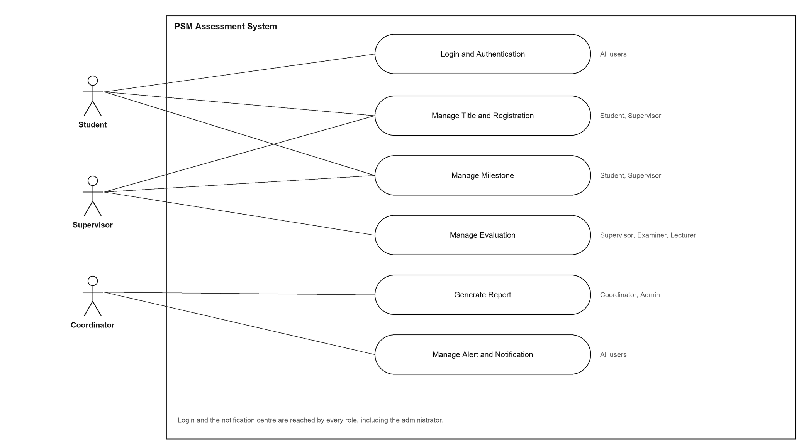
Figure 4.1: Use Case Diagram

4.2.2 Use Case Specification
This section specifies each use case in turn. Every specification carries its history log and its actors. It also carries its normal flow, its alternative flows and its exceptions. Each table ends with the requirements it satisfies. Both diagrams for the use case follow beneath the table.

Use Case 1: Login and Authentication
Table 4.4: Login and Authentication Use Case Specification
History Log | 1.0.0  Create initial use case.
History Log | 2.0.0  Added history log.  Added account lockout and the audit entry.
Version | 2.0.0
Use Case ID | UC-01
Use Case Name | Login and Authentication
Created By | Tan Yue Heng | Updated By | Tan Yue Heng
Date Created | 28.10.2025 | Last Revision Date | 1.11.2025
Actors | Student, Supervisor, Lecturer, Coordinator, Admin.
Description | The user signs in with an email address and a password. The system checks the credentials and either issues a session token and sends the user to the dashboard for their role, or refuses the attempt.
Preconditions | The user holds an account, and the account is active.
Post conditions | The user is signed in and holds a session token, or remains on the login form and the attempt is recorded.
Normal Flow | 1.0 User Sign In  1. The user opens the login page.  2. The user enters an email address and a password.  3. The system checks that both fields are present and that the address is well formed.  4. The system finds the account and verifies the password against its hash.  5. The system confirms that the account is not locked and is active.  6. The system creates a session token and resets the failed attempt counter.  7. The system records the sign-in in the audit log.  8. The system sends the user to the dashboard for their role.
Alternative Flow | A.1 Missing or malformed input  1. The system returns a validation error.  2. The user corrects the entry and resubmits.  A.2 Unknown account or wrong password  1. The system records the attempt.  2. The system shows the general failure message.  A.3 Account locked after repeated failures  1. The system refuses the attempt until the lock expires.  A.4 Account inactive or suspended  1. The system refuses the attempt.
Exceptions | E.1 The credential check fails for any reason  The system shows the same message for an unknown account and a wrong password, so the form cannot be used to discover which addresses exist.
Related requirement | ID | Requirement | Priority
 | FR01 | The system shall authenticate a user with a valid email address and password. | Basic
 | FR02 | The system shall issue a session token and send the user to their role's dashboard. | Basic
 | FR03 | The system shall refuse every failed sign-in with one message, and lock an account after five attempts. | Basic

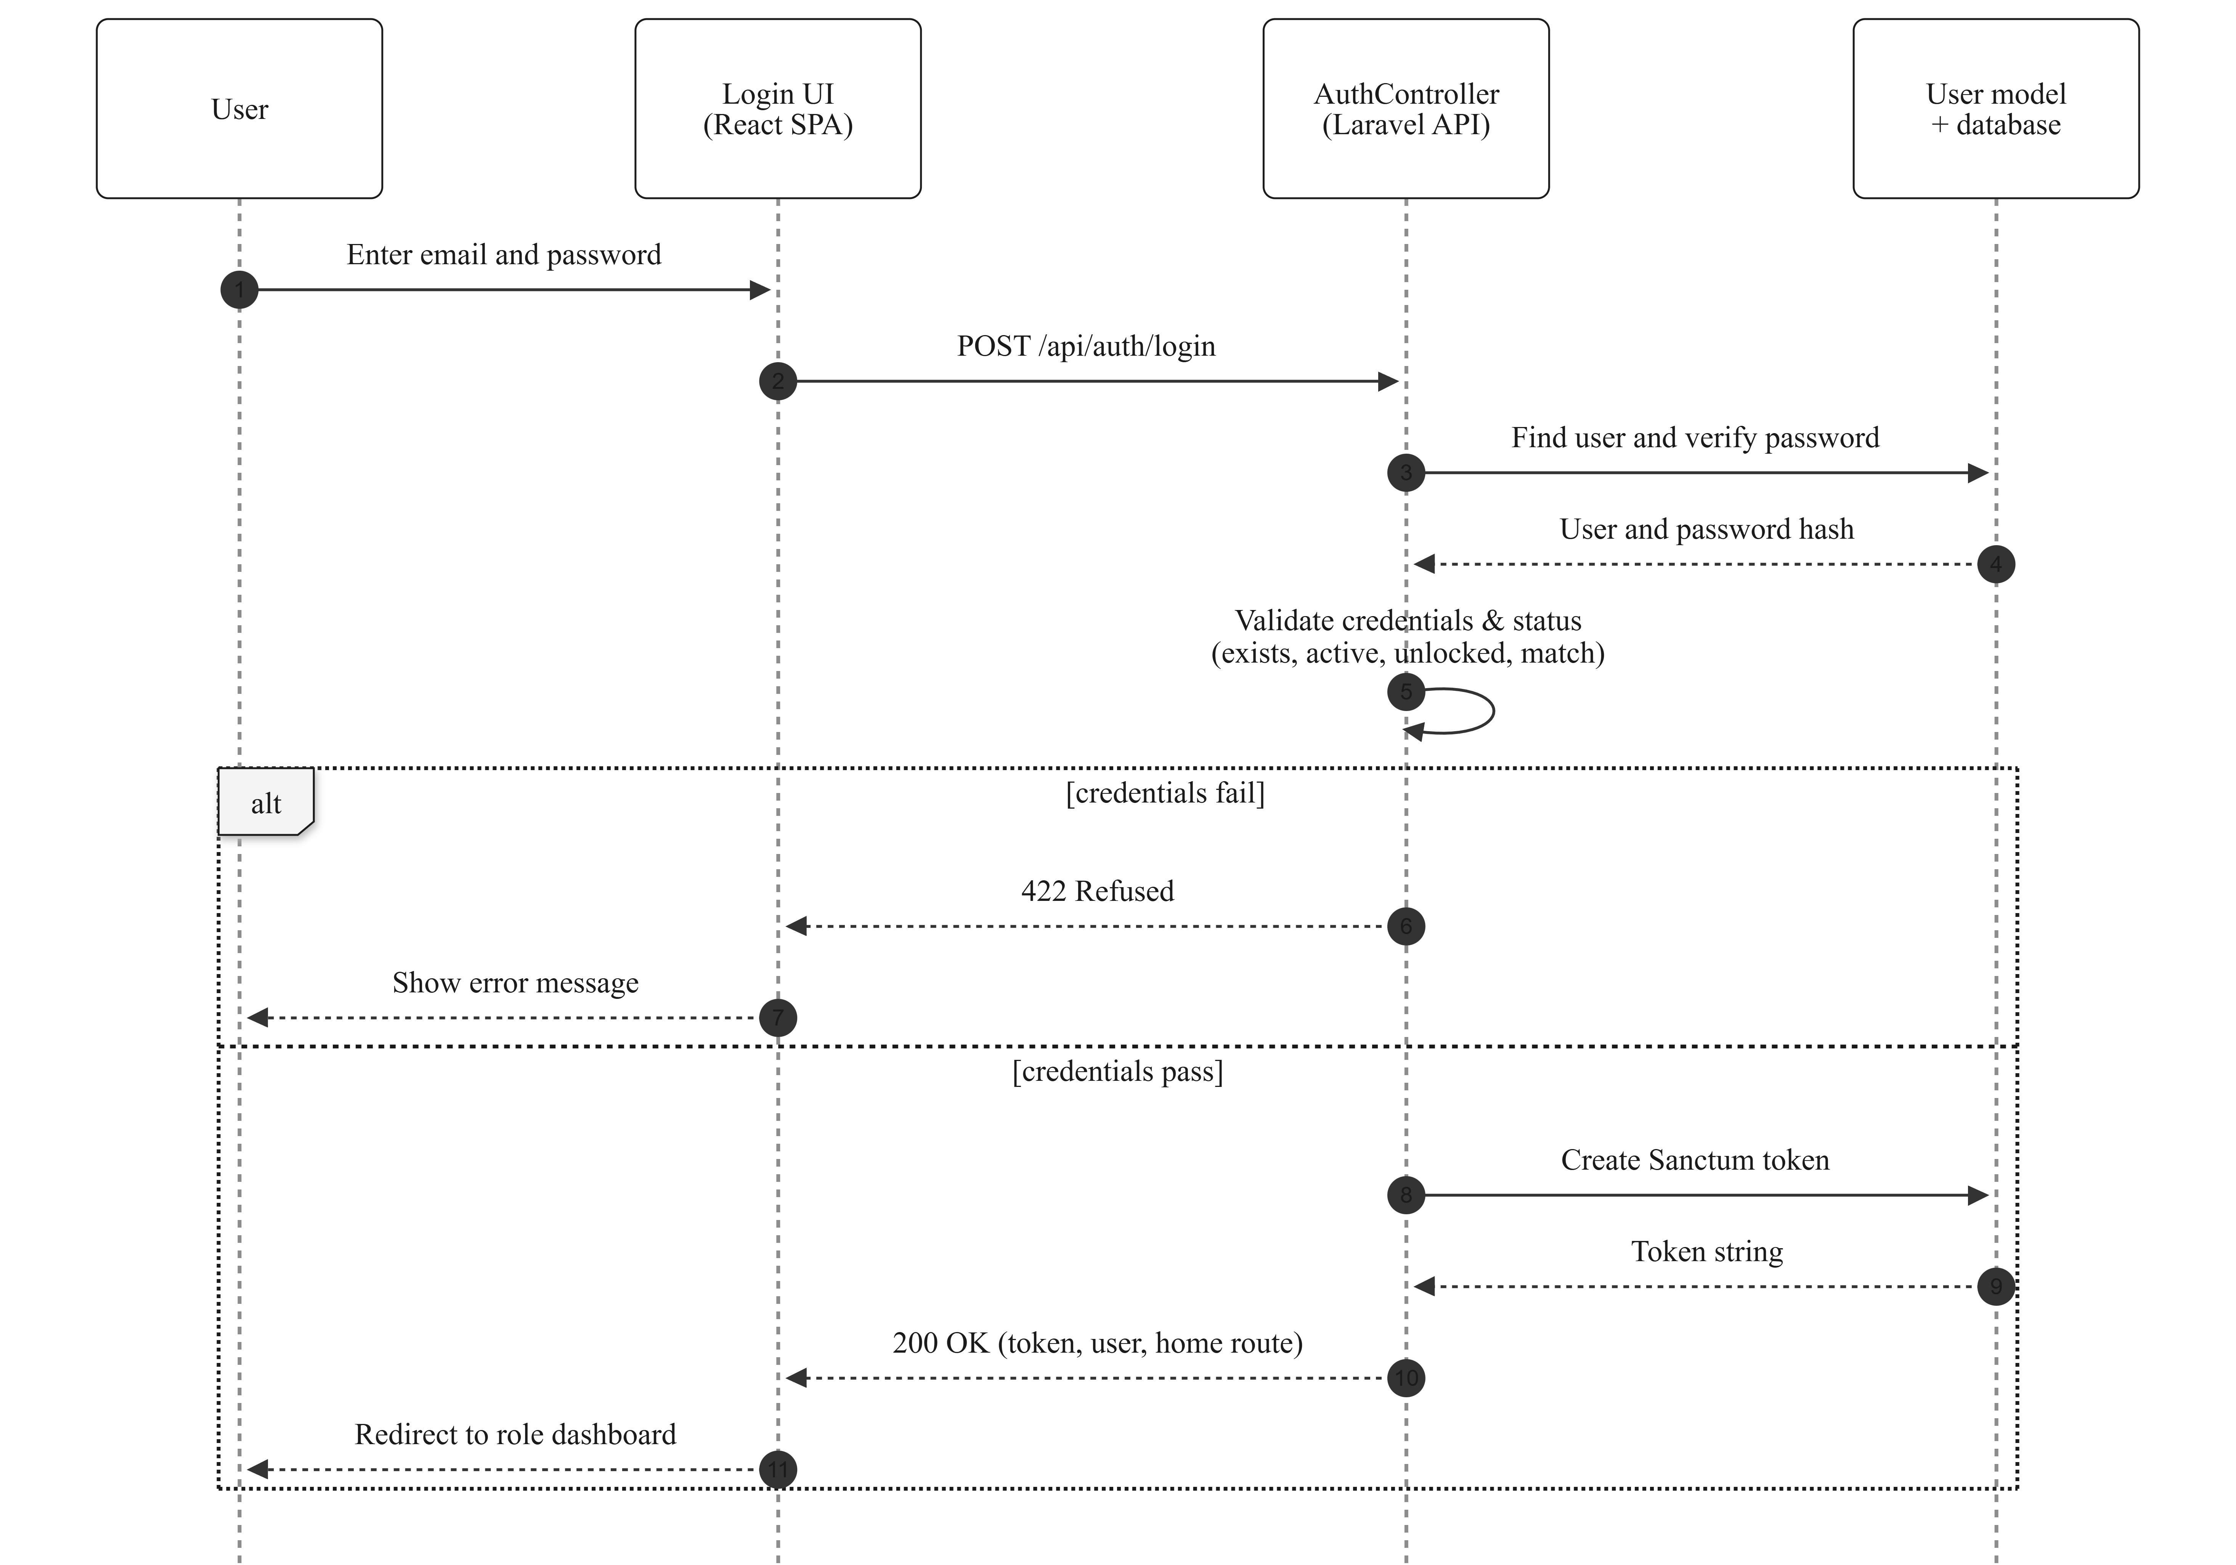
Figure 4.2: Sequence Diagram for Login and Authentication
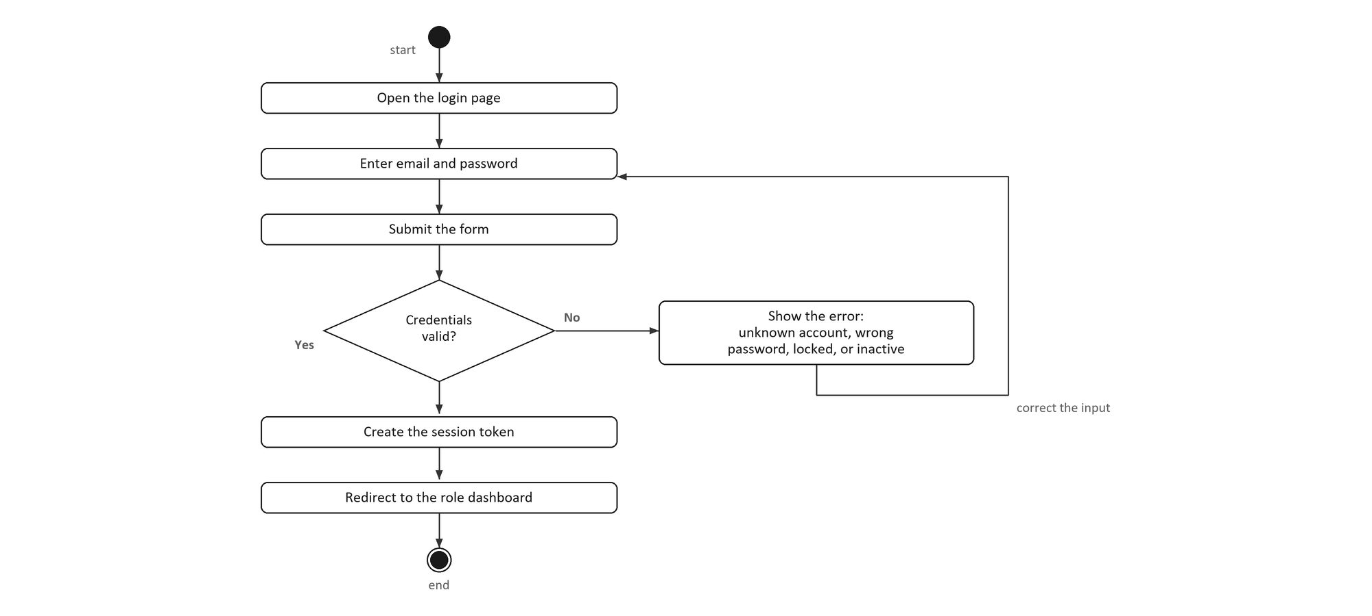
Figure 4.3: Activity Diagram for Login and Authentication

Use Case 2: Manage Title and Registration
Table 4.5: Manage Title and Registration Use Case Specification
History Log | 1.0.0  Create initial use case.
History Log | 2.0.0  Added history log.  Lampiran B becomes a record, and a refused title is re-presented.
Version | 2.0.0
Use Case ID | UC-02
Use Case Name | Manage Title and Registration
Created By | Tan Yue Heng | Updated By | Tan Yue Heng
Date Created | 28.10.2025 | Last Revision Date | 1.11.2025
Actors | Student (primary), Supervisor (primary). Coordinator and Admin may view and audit.
Description | The student registers for PSM 1 by filing Lampiran A. That form records their particulars, up to three proposed titles and the supervisor they approached. The supervisor acknowledges the agreement and chooses which title the student will register. The acknowledgement also creates the supervision. The student then files Lampiran B, and the supervisor signs it. Signing opens the proposal milestone.
Preconditions | The student is signed in and an academic term is open for registration. The student holds no project and no agreement in flight for that term. The named supervisor serves the student's programme and has capacity for the part.
Post conditions | The student holds an approved agreement naming one agreed title. A supervision exists, and the proposal milestone is open. The project's title is not fixed here: it becomes the project's title only when a panel accepts it.
Normal Flow | 1.0 Manage Title and Registration  1. The student opens Lampiran A and selects the session from the open terms.  2. The student enters their particulars and proposes up to three titles.  3. The student names a supervisor and submits the form.  4. The system confirms that a term is open, and that the student holds no project and no agreement.  5. The system validates each proposed title.  6. The system confirms that the supervisor serves the student's programme.  7. The system creates the agreement and notifies the supervisor.  8. The supervisor opens the agreement and chooses one proposed title.  9. The system confirms that the chosen title is one the student proposed.  10. The system creates the supervision and records the agreed title.  11. The student files Lampiran B.  12. The supervisor signs the form, which opens the proposal milestone.
Alternative Flow | A.1 No term is open, or a project or agreement already exists  1. The system refuses the filing and names which condition applies.  A.2 A proposed title is unusable  1. The system refuses it and the student corrects it.  A.3 The supervisor does not serve the student's programme  1. The submission is refused.  2. An unrecorded programme is allowed through, so legacy staff are not locked out.  A.4 The supervisor names a title the student did not propose  1. The system refuses it, because the acknowledgement is a choice between the candidates.  A.5 The supervisor sends Lampiran B back  1. The form returns to the student as a draft with a reason.  A.6 The student withdraws the filing before a project is registered  1. The agreement is cancelled and the supervision is retired.  2. The pending form is cleared.
Exceptions | E.1 A title refused by the panel is re-presented on a new Lampiran B  The new form needs a new signature, because a signature on one title does not cover another. Nothing is overwritten, so the refusal stays on record.
Related requirement | ID | Requirement | Priority
 | FR04 | The system shall offer only the academic sessions that are open for registration. | Basic
 | FR05 | The system shall require the supervisor to serve the student's programme, failing open when none is recorded. | Basic
 | FR06 | The system shall accept only a title the student proposed as the agreed title. | Basic
 | FR07 | The system shall let a student withdraw a filing until a project is registered from it. | Average

Figure 4.4: Sequence Diagram for Manage Title and Registration
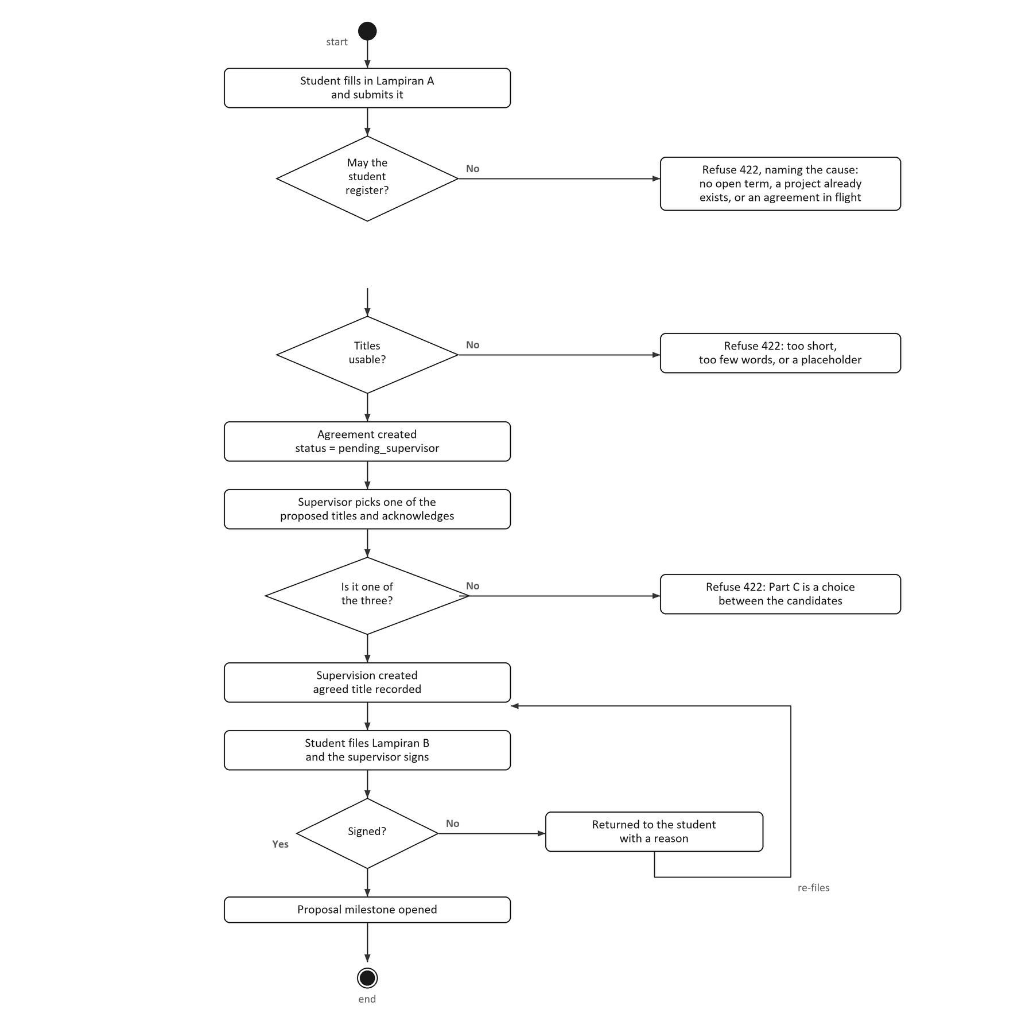
Figure 4.5: Activity Diagram for Manage Title and Registration

Use Case 3: Manage Milestone
Table 4.6: Manage Milestone Use Case Specification
History Log | 1.0.0  Create initial use case.
History Log | 2.0.0  Added history log.  The supervisor endorses the proposal before the panel sees it.
Version | 2.0.0
Use Case ID | UC-03
Use Case Name | Manage Milestone
Created By | Tan Yue Heng | Updated By | Tan Yue Heng
Date Created | 28.10.2025 | Last Revision Date | 1.11.2025
Actors | Student (submits), Supervisor (reviews), Coordinator and Admin (deadline), Panel (the proposal's verdict).
Description | The system generates a milestone chain for a project and opens its milestones in order. A student submits work to the open milestone, and a reviewer approves it or requests a revision. Approval opens the next milestone. A revision request reopens the same one.
Preconditions | The project is registered, its chain has been generated, and the milestone is open.
Post conditions | The milestone is approved and the next one is open, or it has been returned to the student with the revision count increased.
Normal Flow | 1.0 Submit and Review a Milestone  1. The coordinator registers the project and the chain is generated.  2. The system opens the first milestone.  3. The student uploads the work.  4. The system confirms that the chain has opened the milestone.  5. The supervisor opens the submitted work.  6. The supervisor approves it or requests a revision.  7. The system confirms that the actor may review and that the status allows the move.  8. The system saves the status, the reviewer and the comment.  9. The system opens the next milestone in the chain.  10. The system notifies the student.
Alternative Flow | A.1 The upload reaches a milestone the chain has not opened  1. The system refuses it.  A.2 The supervisor requests a revision  1. The status becomes rejected and the revision counter increases.  2. The milestone reopens for a new upload.  A.3 The supervisor sends the proposal back  1. The same transition is used.  2. The chain does not advance.  A.4 The milestone is the proposal  1. Approving it does not open the chain, because its verdict belongs to the panel.
Exceptions | E.1 No milestone remains after an approval  The project is recorded as complete for that part.
Related requirement | ID | Requirement | Priority
 | FR08 | The system shall generate the chain when a project is registered, and open one milestone at a time. | Basic
 | FR09 | The system shall refuse an upload to a milestone the chain has not opened. | Basic
 | FR10 | The system shall open the next milestone only when the current one is approved. | Basic
 | FR11 | The system shall accept a late upload but flag it as late to the reviewer. | Average

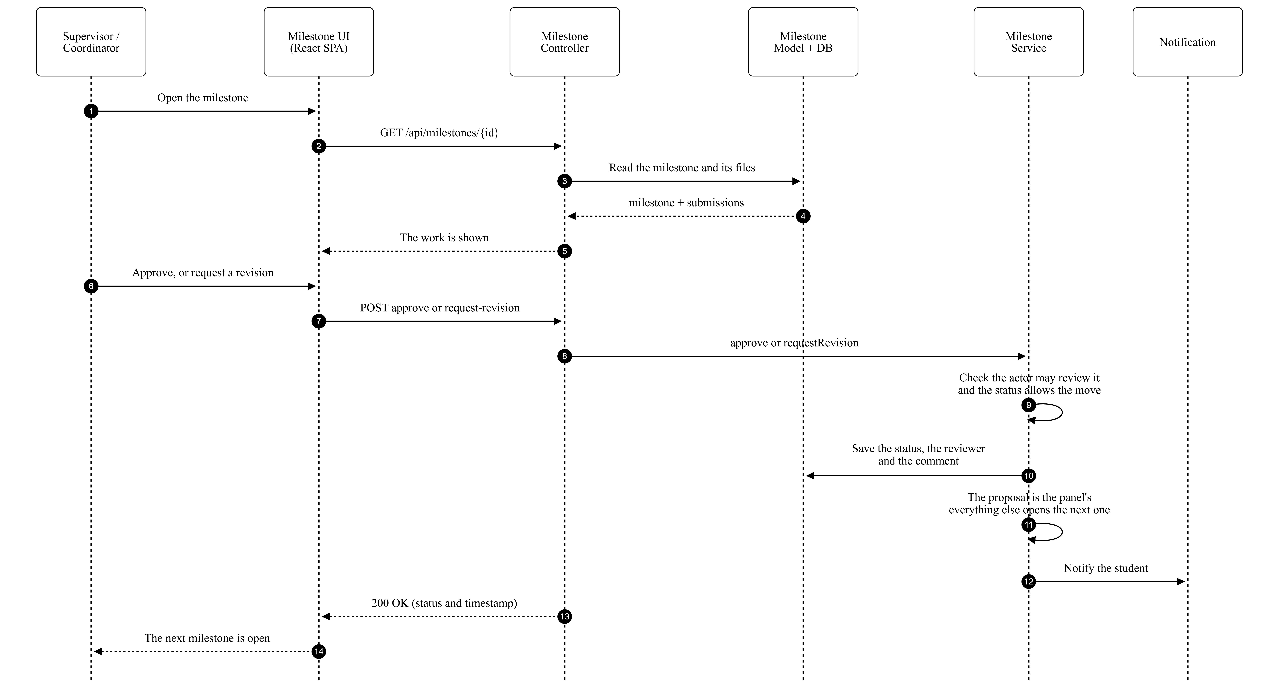
Figure 4.6: Sequence Diagram for Manage Milestone
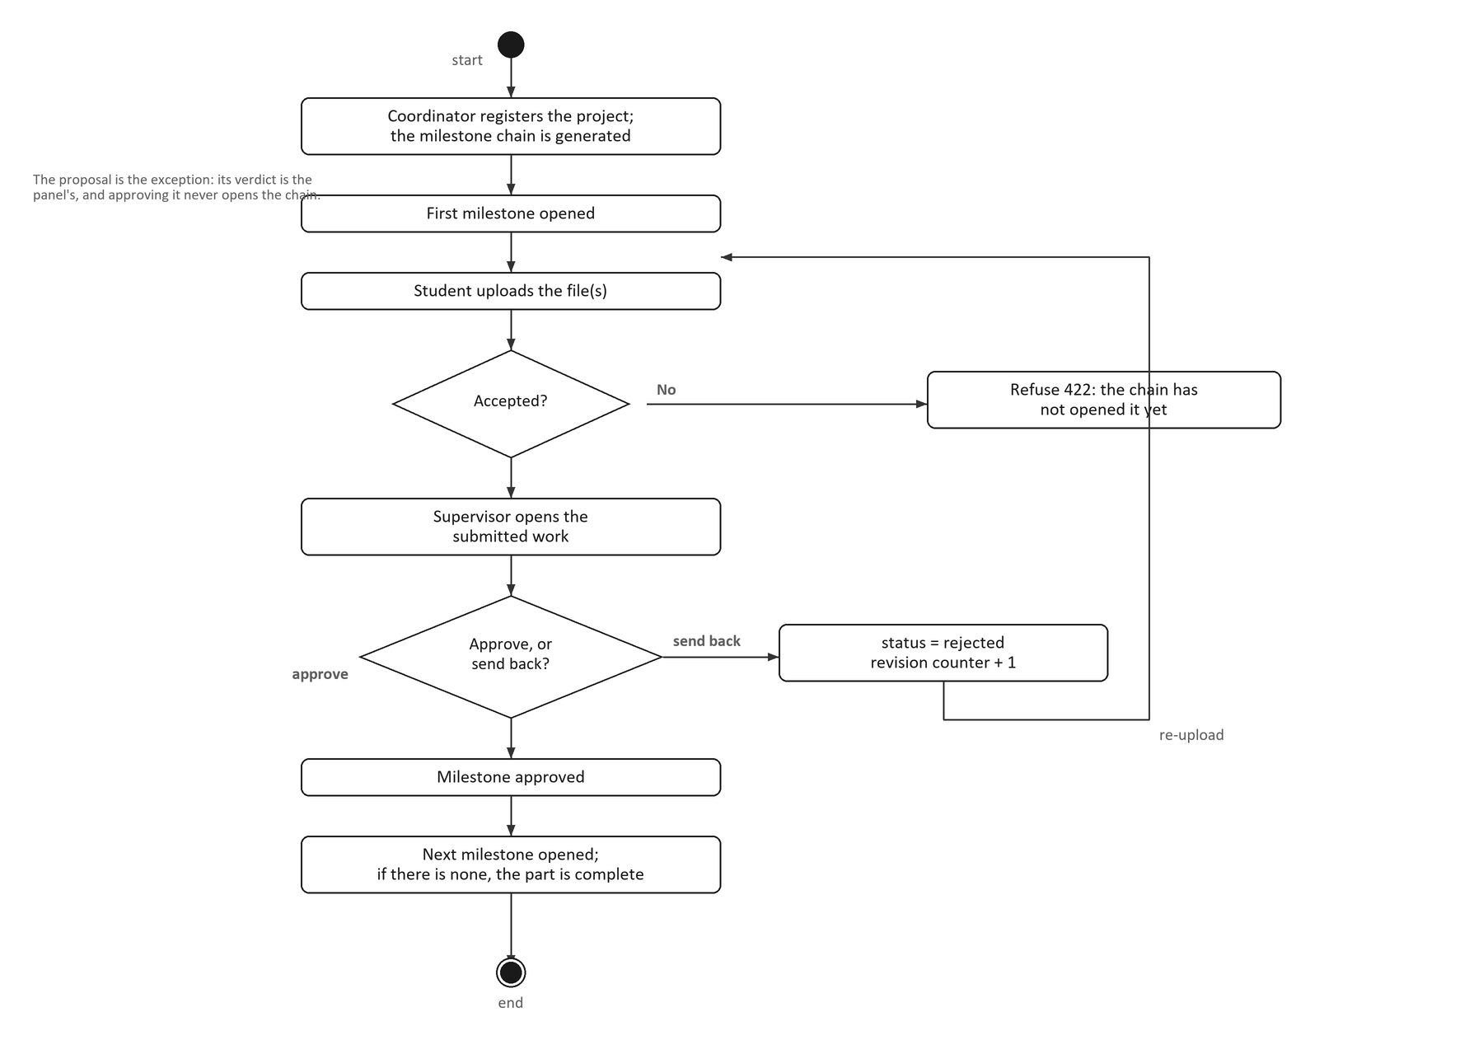
Figure 4.7: Activity Diagram for Manage Milestone

Use Case 4: Manage Evaluation
Table 4.7: Manage Evaluation Use Case Specification
History Log | 1.0.0  Create initial use case.
History Log | 2.0.0  Added history log.  Mark entry moves to the 0 to 5 scale, and the release step is removed.
Version | 2.0.0
Use Case ID | UC-04
Use Case Name | Manage Evaluation
Created By | Tan Yue Heng | Updated By | Tan Yue Heng
Date Created | 28.10.2025 | Last Revision Date | 1.11.2025
Actors | Assessor, being the supervisor, an examiner or a lecturer (primary). Coordinator allocates the forms.
Description | The assessor opens the form allocated to them and marks each criterion on a 0 to 5 scale. The system converts each item score to the rubric's own weight, so a Lampiran still totals what the form says while the marker answers on one scale. When every criterion is marked the assessor submits. That locks the form, recomputes the project's aggregate and makes the mark visible in the same step.
Preconditions | The coordinator has allocated the form to the assessor and opened the assessment window for that form. The milestones the form depends on are approved.
Post conditions | The form is submitted and locked, and the aggregate has been recomputed. The student can see the mark. The item scores, the converted marks, the submitter and the time are all retained.
Normal Flow | 1.0 Mark and Submit a Form  1. The assessor opens an allocated form.  2. The system loads the rubric and the existing scores.  3. The system shows one 0 to 5 select per criterion.  4. The assessor chooses a score for each criterion and may add a comment.  5. The system confirms that the form is editable and that its window is open.  6. The system converts each item score to the criterion's weight and stores both.  7. The assessor submits the form.  8. The system confirms that every criterion is marked.  9. The system locks the form, recomputes the final mark and publishes it.  10. The system notifies the coordinator and the student.
Alternative Flow | A.1 The form's own window is not open  1. The mark is refused. The window is per form, so opening Lampiran E does not open Lampiran I.  A.2 The form is already submitted  1. It is locked and refuses the change.  A.3 An item score is outside 0 to 5  1. It is refused and the assessor corrects it.  A.4 A criterion is unmarked at submission  1. The submission is refused and each unmarked criterion is named.  A.5 A dependent milestone is not approved  1. The submission is refused.  A.6 The assessor declares a conflict of interest  1. The form is marked recused and the coordinators are notified, so a replacement can be allocated.
Exceptions | E.1 A student who did not attend is assessed as zero  The assessor types that zero. The system never assumes one, because an incomplete form is refused while an assessed zero is complete.
Related requirement | ID | Requirement | Priority
 | FR12 | The system shall present one 0 to 5 score per rubric criterion. | Basic
 | FR13 | The system shall convert each item score to the criterion's weight and total each Lampiran as the form defines it. | Basic
 | FR14 | The system shall refuse a mark before that form's assessment window is open. | Basic
 | FR15 | The system shall publish the final mark to the student when the assessor submits. | Basic

Figure 4.8: Sequence Diagram for Manage Evaluation
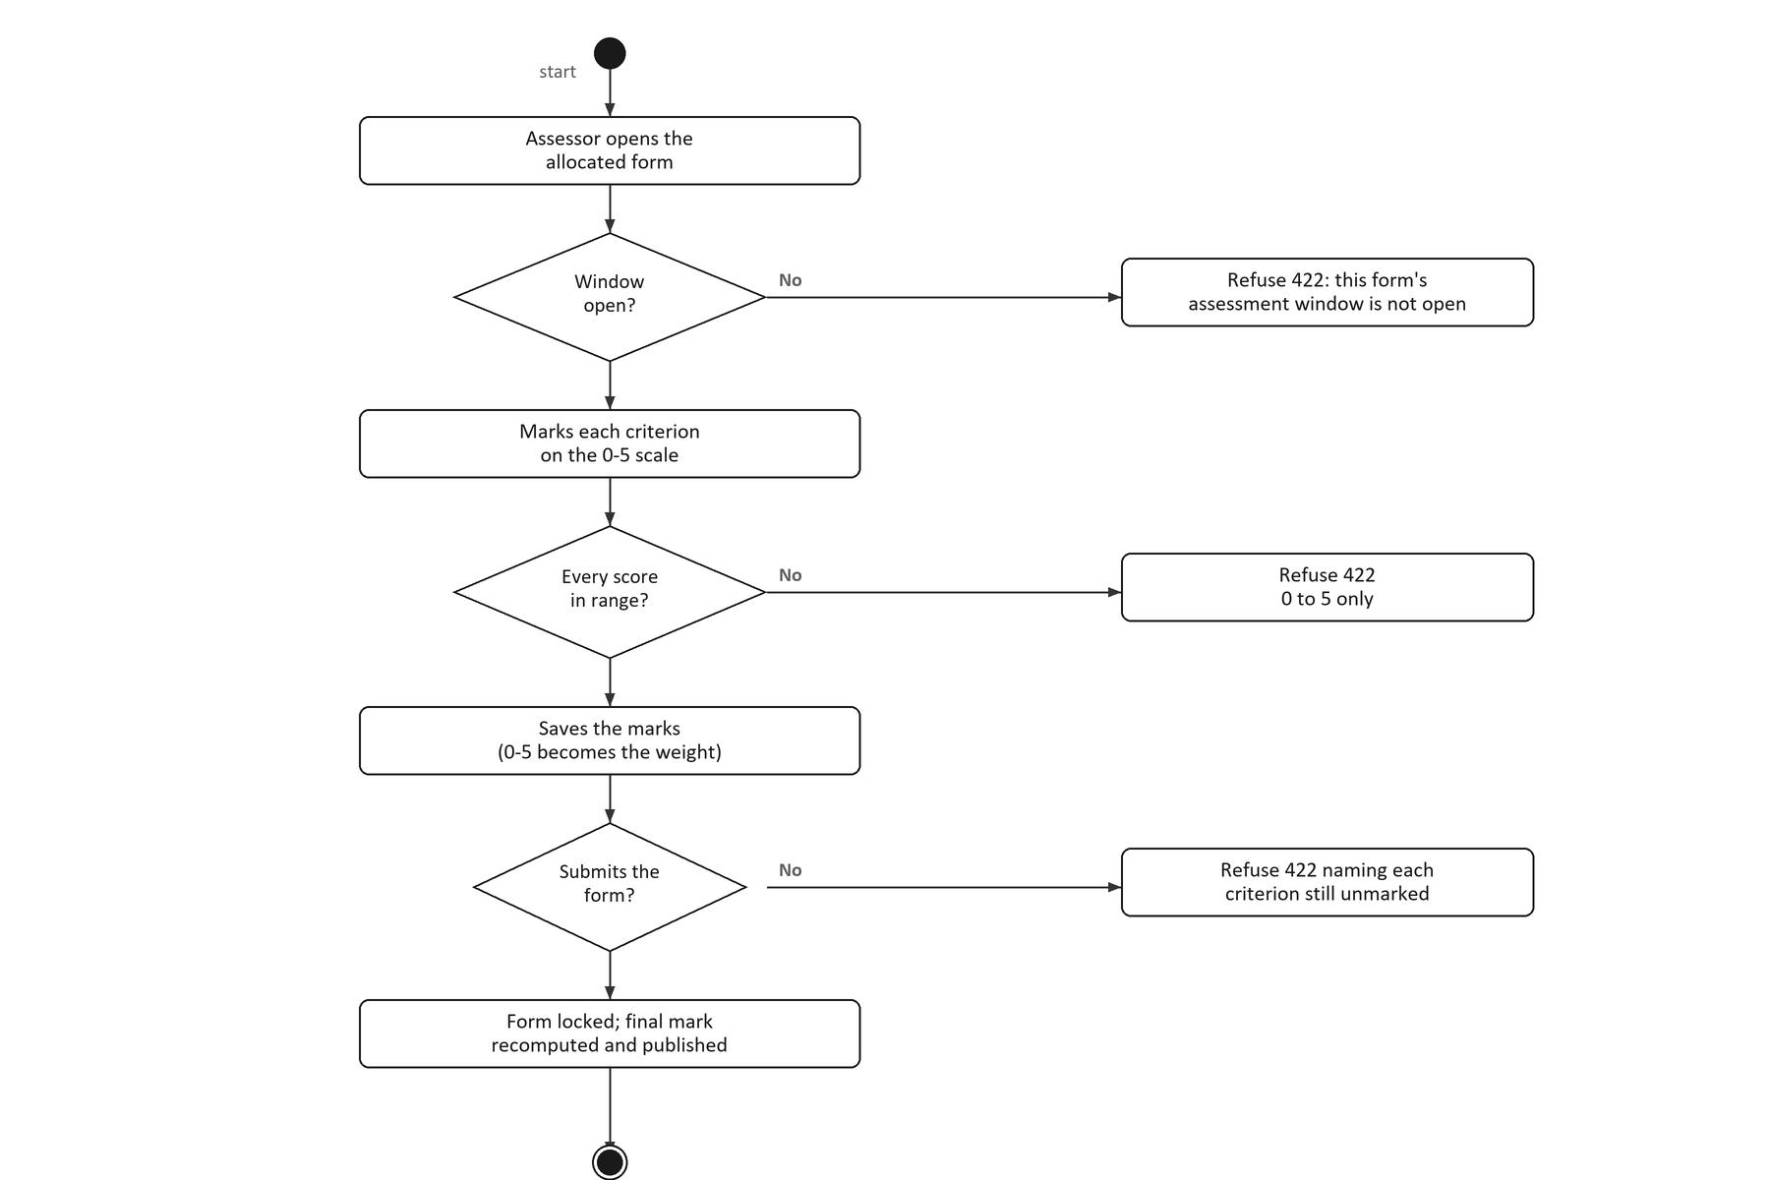
Figure 4.9: Activity Diagram for Manage Evaluation

Use Case 5: Generate Report
Table 4.8: Generate Report Use Case Specification
History Log | 1.0.0  Create initial use case.
History Log | 2.0.0  Added history log.  Added the CSV export and its audit entry.
Version | 2.0.0
Use Case ID | UC-05
Use Case Name | Generate Report
Created By | Tan Yue Heng | Updated By | Tan Yue Heng
Date Created | 28.10.2025 | Last Revision Date | 1.11.2025
Actors | Coordinator (primary), Admin.
Description | The coordinator selects a batch, a PSM part and a semester. The system then produces cohort analytics. These cover progress, students at risk, supervisor and examiner workload, mark distribution and the milestone breakdown. The coordinator may also export the grade or project list as a CSV file.
Preconditions | The coordinator is signed in and holds the analytics permission. Projects and assessments exist for the chosen filters.
Post conditions | The coordinator sees figures for the chosen filters, or receives a CSV file. The export is recorded in the audit log. No underlying data is modified.
Normal Flow | 1.0 Generate a Report  1. The coordinator opens the report screen.  2. The coordinator chooses the batch, the PSM part and the semester.  3. The system confirms that the caller may view cohort analytics.  4. The system aggregates progress, students at risk, workload and mark bands.  5. The system returns the figures and the interface renders them.  6. For an export, the system applies the narrower export permission.  7. The system records the export and streams the rows.  8. The coordinator saves the file.
Alternative Flow | A.1 The caller may not view analytics  1. The system returns 403 Forbidden.  A.2 A filter names a semester that does not exist  1. The filters are rejected.  A.3 The coordinator chooses an export  1. The export permission is narrower, and is limited to coordinators and administrators.  A.4 No grade has been released  1. The mark distribution returns empty bands rather than zero, because no mark is not a mark of zero.
Exceptions | E.1 A grade without a final mark is exported  It carries a blank verdict rather than a fail, and is excluded from the displayed pass rate.
Related requirement | ID | Requirement | Priority
 | FR16 | The system shall produce cohort progress, at-risk students, workload and mark distribution. | Basic
 | FR17 | The system shall export the grade or project list as a CSV file. | Basic
 | FR18 | The system shall record every export in the audit log with its filters. | Average

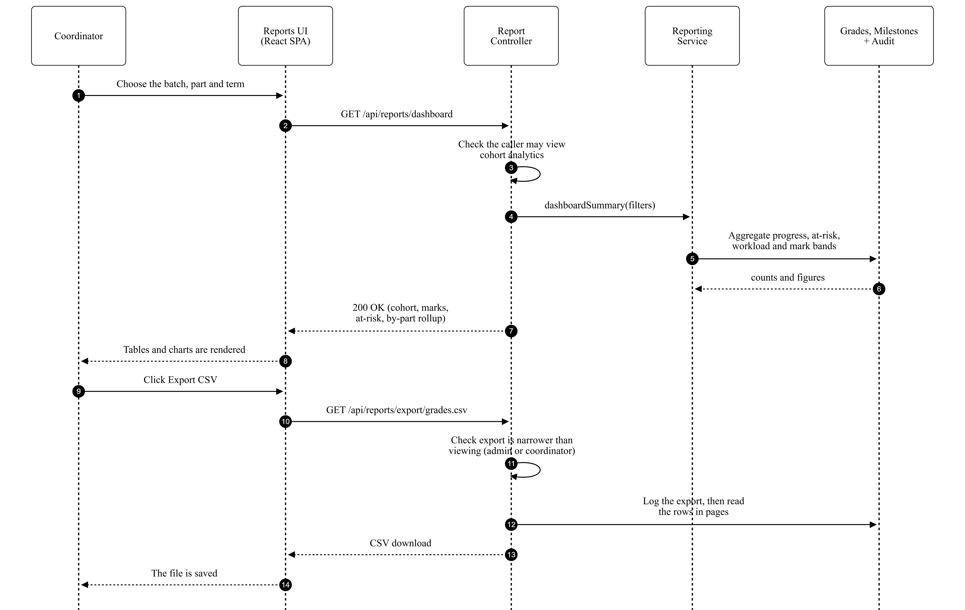
Figure 4.10: Sequence Diagram for Generate Report
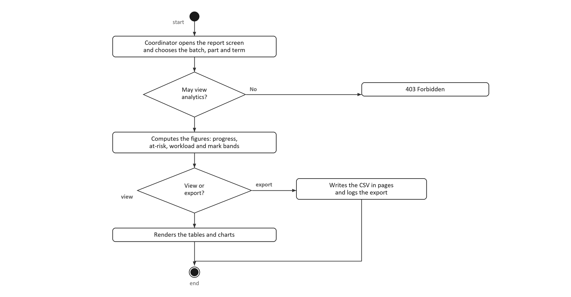
Figure 4.11: Activity Diagram for Generate Report

Use Case 6: Manage Alert and Notification
Table 4.9: Manage Alert and Notification Use Case Specification
History Log | 1.0.0  Create initial use case.
History Log | 2.0.0  Added history log.  Added the de-duplication ledger and the preference rules.
Version | 2.0.0
Use Case ID | UC-06
Use Case Name | Manage Alert and Notification
Created By | Tan Yue Heng | Updated By | Tan Yue Heng
Date Created | 28.10.2025 | Last Revision Date | 1.11.2025
Actors | System scheduler (primary, for the reminders). Every signed-in user (for the notification centre).
Description | The system sends deadline reminders seven, three and one days before a milestone is due. It records each one so a retried run cannot send it twice. Every user has a notification centre where they read and dismiss items and choose which types they receive.
Preconditions | Milestones with deadlines exist for the reminder run. The user is signed in for the centre.
Post conditions | A reminder has been sent once per recipient per wave, and is recorded in the ledger. Changes to preferences are saved.
Normal Flow | 1.0 Send a Deadline Reminder  1. The scheduled command runs.  2. The system finds the milestones due in seven, three or one days.  3. The system checks that each user is active, has not opted out, and has not already been sent this wave.  4. The system writes the in-app record and sends the mail.  5. The system records the dispatch in the ledger.  6. The system moves to the next wave or finishes.  2.0 Use the Notification Centre  1. The user opens the notification centre.  2. The user reads or dismisses an item.  3. The user may change which notification types they receive.
Alternative Flow | A.1 Nothing is due in a wave  1. The run moves to the next wave.  A.2 The wave was already sent to this recipient  1. It is skipped, which is what keeps a retried run safe.  A.3 The user opted out of that type, or is inactive  1. Nothing is sent.  A.4 The user turns off a type the faculty treats as mandatory  1. The change is ignored, so those notifications always arrive.
Exceptions | E.1 A mail transport failure occurs  The ledger entry stays unwritten, so the next run retries the same recipient rather than losing the reminder.
Related requirement | ID | Requirement | Priority
 | FR19 | The system shall send a deadline reminder seven, three and one days before a milestone is due. | Basic
 | FR20 | The system shall de-duplicate a reminder so a retried run cannot send it twice. | Basic
 | FR21 | The system shall let a user read, dismiss and choose notification types, except mandatory ones. | Average

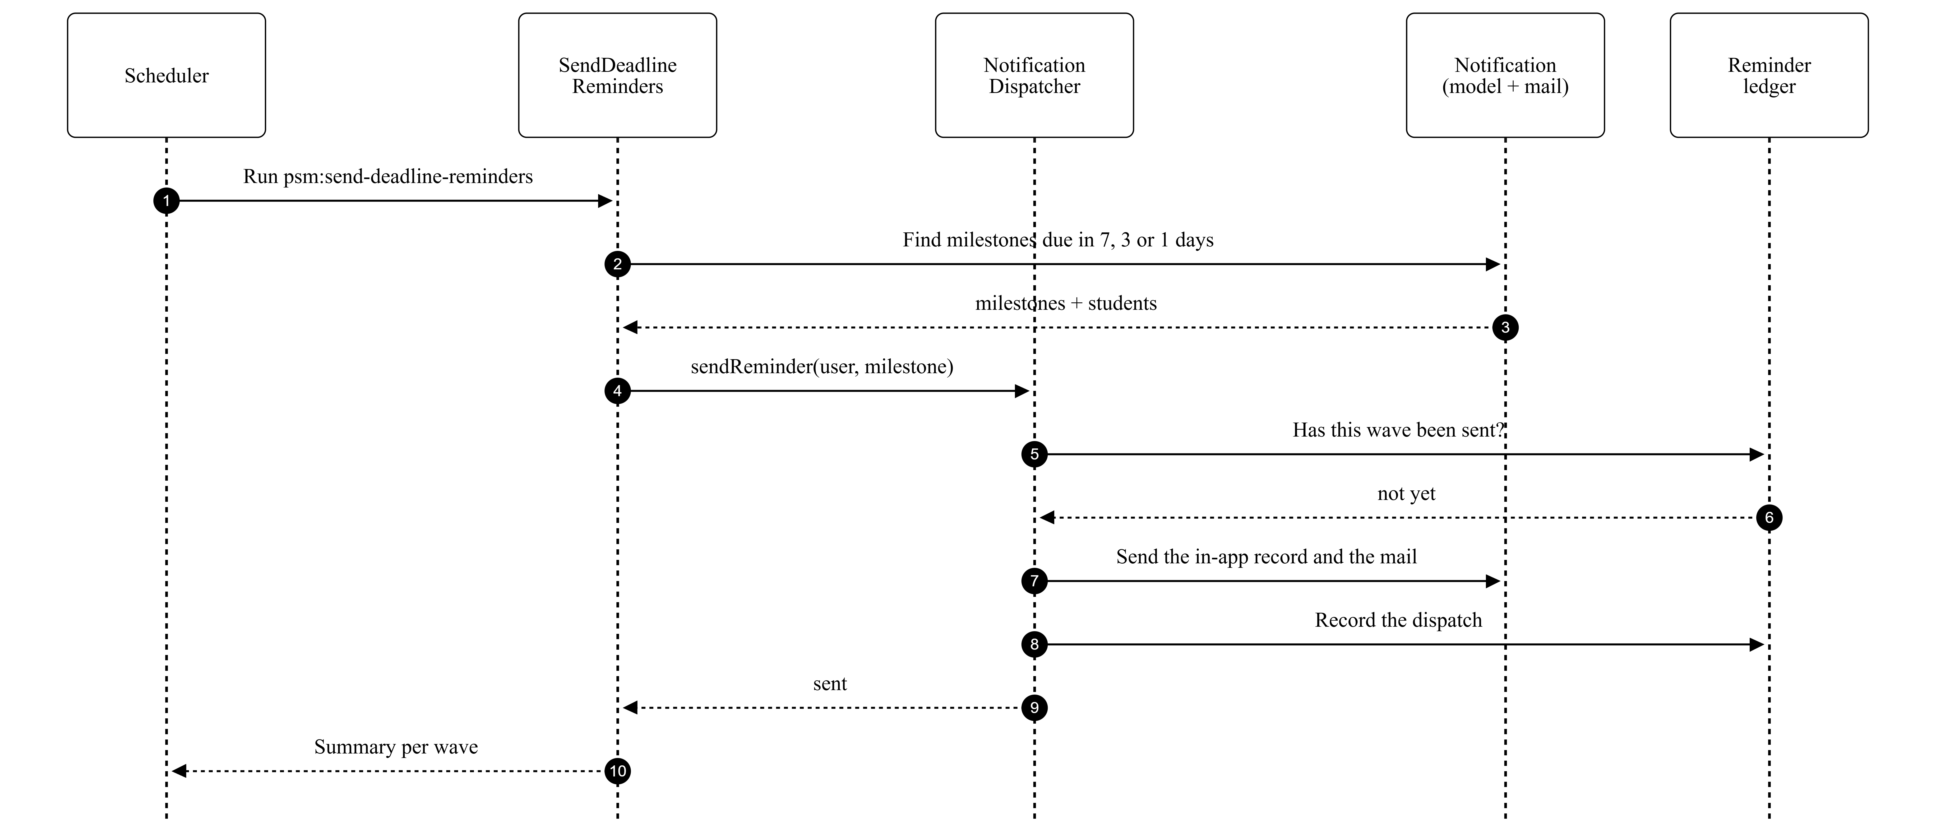
Figure 4.12: Sequence Diagram for Manage Alert and Notification
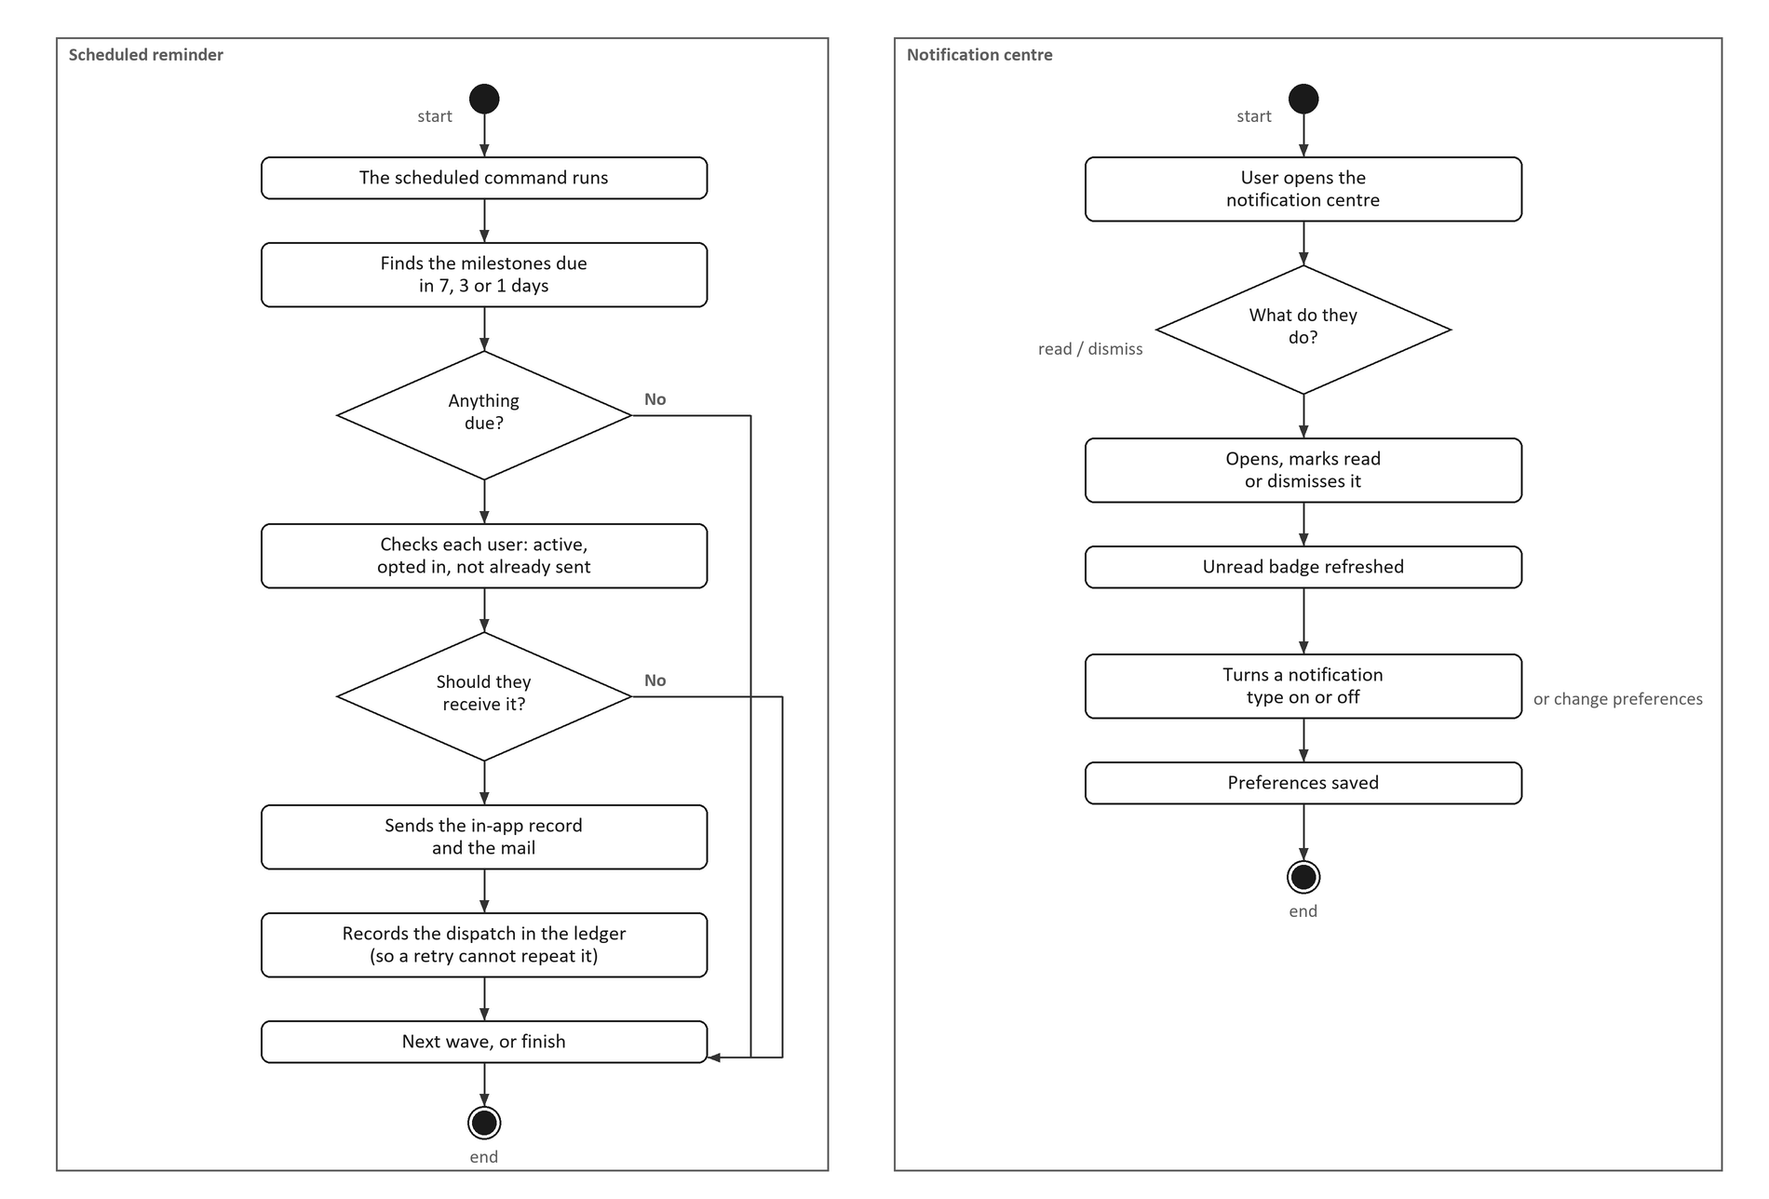
Figure 4.13: Activity Diagram for Manage Alert and Notification

4.2.3 Class Diagram
The class diagram shows the domain classes and their associations. Twelve classes carry the lifecycle. A project holds milestones and members. A milestone holds submissions and its review. A project holds a final grade and a set of mark submissions. Behind these sit four records. These are the Lampiran B filings, the enrolments, the supervisions and the panel seats.

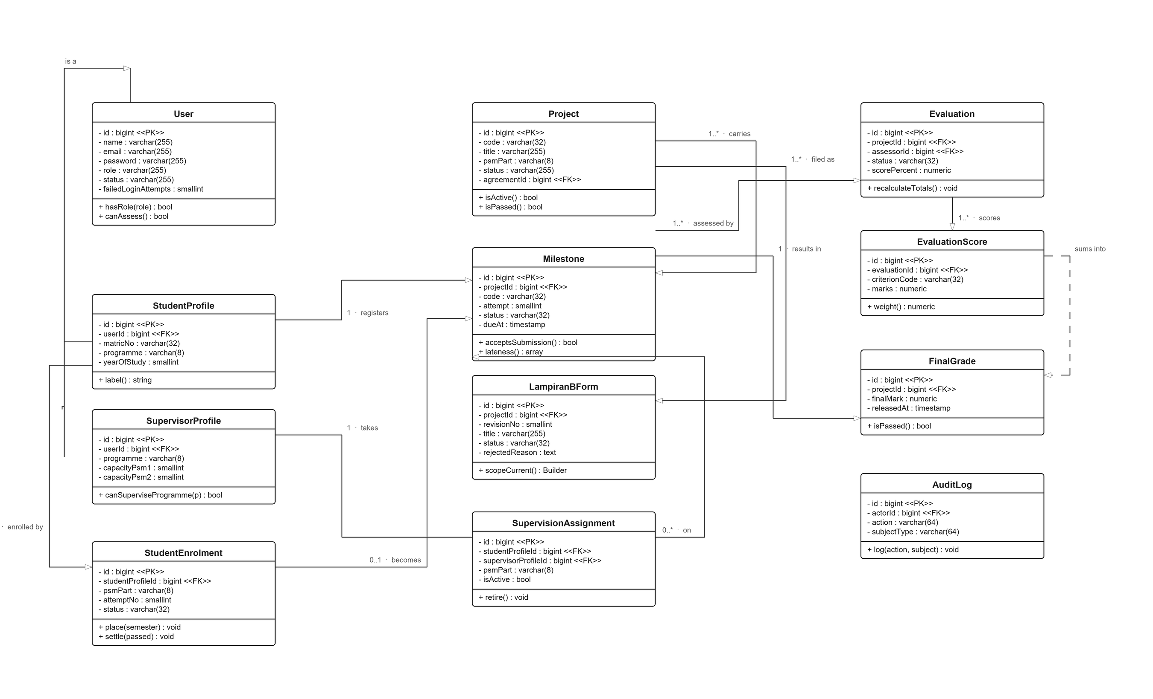
Figure 4.14: Class Diagram

4.3 Database Design
The database is PostgreSQL. It holds one schema for the whole lifecycle. Every rule the analysis describes is enforced here too. A rule that can be a constraint is written as one. An application bug cannot then write a state the analysis forbids. The data dictionary below is generated from the live schema. Its types and sizes are therefore what the database holds.

4.3.1 Schema Summary
Table 4.10 lists the core tables and what each one is for.

Table 4.10: Core Tables
No | Table | Purpose
1 | users | One row per account, with the role that decides what the account may reach.
2 | student_profiles | A student's particulars: matric number, programme, batch and the term of their intake.
3 | supervisor_profiles | An academic's staff number, programme ownership and supervision capacity.
4 | projects | The project itself, including its PSM part and the title a panel has accepted.
5 | supervisor_agreements | Lampiran A: what the student filed, and the supervisor's acknowledgement of it.
6 | lampiran_b_forms | Every Lampiran B filing, revision by revision, with the panel's reason for any refusal.
7 | milestones | One row per step of a project's chain, including its attempt number and its status.
8 | student_enrolments | A student's place in one PSM part for one term. This is where a student's term lives.

4.3.2 Users Table
Table 4.11: users table
Column | Type | Key | Null | Description
id | bigint(11) | PK | No | Primary key
name | character varying(255) |  | No | Full name
email | character varying(255) |  | No | Sign-in address, unique
email_verified_at | timestamp without time zone |  | Yes | —
password | character varying(255) |  | No | Bcrypt hash; never the plain text
role | character varying(255) |  | No | student, supervisor, lecturer, coordinator or admin
status | character varying(255) |  | No | active, inactive, suspended or pending
phone | character varying(32) |  | Yes | —
avatar_path | character varying(255) |  | Yes | —
staff_id | character varying(64) |  | Yes | —
department | character varying(255) |  | Yes | —
must_change_password | boolean |  | No | Forces a password change on next sign-in
last_login_at | timestamp without time zone |  | Yes | Last successful sign-in
last_login_ip | character varying(45) |  | Yes | —
failed_login_attempts | smallint(11) |  | No | Consecutive failures, reset on success
locked_until | timestamp without time zone |  | Yes | Lockout expiry after repeated failures
notification_preferences | json |  | Yes | —
digest_only | boolean |  | No | —
remember_token | character varying(100) |  | Yes | —
created_at | timestamp without time zone |  | Yes | —
updated_at | timestamp without time zone |  | Yes | —
deleted_at | timestamp without time zone |  | Yes | —

4.3.3 Student Profiles Table
Table 4.12: student_profiles table
Column | Type | Key | Null | Description
id | bigint(11) | PK | No | Primary key
user_id | bigint(11) | FK | No | The account this profile belongs to
student_id | character varying(32) |  | No | Matric number, unique
program | character varying(128) |  | No | —
program_code | character varying(32) |  | Yes | BIS, BIM, BIP, BIW or BIT
batch | character varying(32) |  | No | Cohort year
faculty | character varying(255) |  | Yes | Always FSKTM
current_semester | smallint(11) |  | Yes | —
phone_emergency | character varying(32) |  | Yes | —
thesis_title | character varying(255) |  | Yes | —
thesis_abstract | text |  | Yes | —
max_supervisors | smallint(11) |  | No | —
is_active_cohort | boolean |  | No | —
created_at | timestamp without time zone |  | Yes | —
updated_at | timestamp without time zone |  | Yes | —
deleted_at | timestamp without time zone |  | Yes | —
academic_semester_id | bigint(11) | FK | Yes | The term of the intake
section_id | bigint(11) | FK | Yes | —

4.3.4 Supervisor Profiles Table
Table 4.13: supervisor_profiles table
Column | Type | Key | Null | Description
id | bigint(11) | PK | No | Primary key
user_id | bigint(11) | FK | No | The account this profile belongs to
staff_no | character varying(32) |  | No | Staff number, unique
academic_title | character varying(64) |  | Yes | —
office_location | character varying(255) |  | Yes | —
max_supervisees | smallint(11) |  | No | Overall supervision capacity
is_accepting_students | boolean |  | No | Whether new students may be allocated
workload_release_percent | numeric |  | No | —
bio | text |  | Yes | —
created_at | timestamp without time zone |  | Yes | —
updated_at | timestamp without time zone |  | Yes | —
deleted_at | timestamp without time zone |  | Yes | —
max_supervisees_psm1 | smallint(11) |  | Yes | PSM 1 capacity, overriding the overall figure
max_supervisees_psm2 | smallint(11) |  | Yes | PSM 2 capacity, overriding the overall figure
programme | character varying(8) |  | Yes | The programme this academic may supervise and examine

4.3.5 Projects Table
Table 4.14: projects table
Column | Type | Key | Null | Description
id | bigint(11) | PK | No | Primary key
code | character varying(32) |  | No | Human-readable project code
title | character varying(255) |  | No | The last title a panel accepted
abstract | text |  | Yes | —
objectives | text |  | Yes | —
scope | text |  | Yes | —
category | character varying(255) |  | No | The chain template this project follows
psm_part | character varying(255) |  | No | PSM1 or PSM2
academic_session | character varying(32) |  | No | —
batch | character varying(32) |  | No | —
program | character varying(128) |  | Yes | —
status | character varying(255) |  | No | Lifecycle status, derived at term close
created_by | bigint(11) | FK | Yes | —
approved_by | bigint(11) | FK | Yes | —
submitted_at | timestamp without time zone |  | Yes | —
approved_at | timestamp without time zone |  | Yes | —
rejection_reason | text |  | Yes | —
archived_at | timestamp without time zone |  | Yes | Retired project marker
leaderboard_opt_out | boolean |  | No | —
metadata | json |  | Yes | —
created_at | timestamp without time zone |  | Yes | —
updated_at | timestamp without time zone |  | Yes | —
deleted_at | timestamp without time zone |  | Yes | —
agreement_id | bigint(11) | FK | Yes | —
academic_semester_id | bigint(11) | FK | Yes | The term the project runs in

4.3.6 Supervisor Agreements Table
Table 4.15: supervisor_agreements table
Column | Type | Key | Null | Description
id | bigint(11) | PK | No | Primary key
student_profile_id | bigint(11) | FK | No | The student filing Lampiran A
supervisor_profile_id | bigint(11) | FK | Yes | The supervisor approached
session | character varying(32) |  | No | —
psm_part | character varying(255) |  | No | The part registered for
proposed_title_1 | character varying(255) |  | No | —
proposed_title_2 | character varying(255) |  | Yes | —
proposed_title_3 | character varying(255) |  | Yes | —
agreed_title | character varying(255) |  | Yes | The title the supervisor chose from the proposals
english_report | boolean |  | No | —
status | character varying(255) |  | No | pending, acknowledged, withdrawn or registered
student_signed_at | timestamp without time zone |  | Yes | —
supervisor_acknowledged_at | timestamp without time zone |  | Yes | —
jkpsm_received_at | timestamp without time zone |  | Yes | —
decided_by | bigint(11) | FK | Yes | —
decided_at | timestamp without time zone |  | Yes | —
rejection_reason | text |  | Yes | —
supervision_assignment_id | bigint(11) | FK | Yes | —
metadata | json |  | Yes | —
created_at | timestamp without time zone |  | Yes | —
updated_at | timestamp without time zone |  | Yes | —
deleted_at | timestamp without time zone |  | Yes | —
academic_semester_id | bigint(11) | FK | Yes | The term registered for

4.3.7 Lampiran B Forms Table
Table 4.16: lampiran_b_forms table
Column | Type | Key | Null | Description
id | bigint(11) | PK | No | Primary key
project_id | bigint(11) | FK | No | The project this filing belongs to
revision_no | smallint(11) |  | No | Which filing this is: 1, 2, 3 and so on
title | character varying(255) |  | No | The title proposed on this form
project_type | character varying(32) |  | No | —
field_study | character varying(255) |  | Yes | —
req_software | character varying(255) |  | Yes | —
req_hardware | character varying(255) |  | Yes | —
req_technology | character varying(255) |  | Yes | —
origin | character varying(255) |  | Yes | —
supervisor_signature_path | character varying(255) |  | Yes | —
supervisor_signature_disk | character varying(32) |  | Yes | —
supervisor_signed_at | timestamp without time zone |  | Yes | —
supervisor_profile_id | bigint(11) | FK | Yes | —
signature_type | character varying(16) |  | Yes | —
status | character varying(16) |  | No | draft, submitted, endorsed, accepted or rejected
rejected_reason | character varying(255) |  | Yes | The panel's objection, kept for ever
rejected_at | timestamp without time zone |  | Yes | —
rejected_by | bigint(11) | FK | Yes | —
supersedes_id | bigint(11) | FK | Yes | —
superseded_by_id | bigint(11) | FK | Yes | The next filing, when there is one
milestone_id | bigint(11) | FK | Yes | The proposal milestone that carries it
created_at | timestamp without time zone |  | Yes | —
updated_at | timestamp without time zone |  | Yes | —

4.3.8 Milestones Table
Table 4.17: milestones table
Column | Type | Key | Null | Description
id | bigint(11) | PK | No | Primary key
project_id | bigint(11) | FK | No | The project whose chain this belongs to
milestone_template_item_id | bigint(11) | FK | Yes | —
code | character varying(32) |  | No | lampiran_a, proposal, chapter_1 and so on
title | character varying(255) |  | No | —
description | text |  | Yes | —
sequence | smallint(11) |  | No | —
weight_percent | numeric |  | No | —
status | character varying(255) |  | No | locked, open, submitted, reviewed, approved or rejected
opens_at | date |  | Yes | —
due_at | date |  | Yes | The shared deadline for every student
allow_late_submission | boolean |  | No | —
late_window_days | smallint(11) |  | No | —
extended_until | timestamp without time zone |  | Yes | —
reviewed_by | bigint(11) | FK | Yes | —
submitted_at | timestamp without time zone |  | Yes | —
reviewed_at | timestamp without time zone |  | Yes | —
approved_at | timestamp without time zone |  | Yes | When it was approved
review_comment | text |  | Yes | —
revision_count | smallint(11) |  | No | How many times a revision was requested
deadline_overridden_by | bigint(11) | FK | Yes | —
deadline_override_reason | text |  | Yes | —
allowed_file_types | json |  | Yes | —
max_files | smallint(11) |  | No | —
requires_supervisor_approval | boolean |  | No | —
created_at | timestamp without time zone |  | Yes | —
updated_at | timestamp without time zone |  | Yes | —
deleted_at | timestamp without time zone |  | Yes | —
lampiran_c_title | character varying(255) |  | Yes | —
lampiran_c_actions | json |  | Yes | —
lampiran_c_at | timestamp without time zone |  | Yes | —
lampiran_c_by | bigint(11) | FK | Yes | —
deadline_is_fixed | boolean |  | No | —
requires_lampiran_c | text |  | Yes | —
lampiran_c_previous_title | character varying(255) |  | Yes | —
lampiran_c_new_title | character varying(255) |  | Yes | —
lampiran_c_filed_at | timestamp without time zone |  | Yes | —
lampiran_c_filed_by | bigint(11) | FK | Yes | —
supervisor_signature_path | character varying(255) |  | Yes | —
supervisor_signature_disk | character varying(32) |  | Yes | —
supervisor_signature_type | character varying(16) |  | Yes | —
supervisor_signed_at | timestamp without time zone |  | Yes | —
supervisor_signed_by | bigint(11) | FK | Yes | —
lampiran_c_ic_number | character varying(32) |  | Yes | —
lampiran_c_passport_number | character varying(32) |  | Yes | —
lampiran_c_mobile_number | character varying(32) |  | Yes | —
lampiran_c_defense_date | date |  | Yes | —
student_signature_path | character varying(255) |  | Yes | —
student_signature_disk | character varying(32) |  | Yes | —
student_signature_type | character varying(16) |  | Yes | —
student_signed_at | timestamp without time zone |  | Yes | —
attempt | smallint(11) |  | No | Which round of the milestone this is

4.3.9 Student Enrolments Table
Table 4.18: student_enrolments table
Column | Type | Key | Null | Description
id | bigint(11) | PK | No | Primary key
student_profile_id | bigint(11) | FK | No | The student enrolled
academic_semester_id | bigint(11) | FK | Yes | The term of the attempt; null while a repeat is unplaced
psm_part | character varying(8) |  | No | PSM1 or PSM2
attempt_no | smallint(11) |  | No | Which attempt at this part
status | character varying(16) |  | No | enrolling, active, completed, failed or withdrawn
project_id | bigint(11) | FK | Yes | The project this attempt runs
repeats_enrolment_id | bigint(11) | FK | Yes | The failed attempt this one repeats
enrolled_at | timestamp without time zone |  | Yes | —
settled_at | timestamp without time zone |  | Yes | —
note | text |  | Yes | —
enrolled_by | bigint(11) | FK | Yes | —
created_at | timestamp without time zone |  | Yes | —
updated_at | timestamp without time zone |  | Yes | —

4.4 Interface Design
The interface is a single-page React client. It is organised by role. A user therefore sees only the screens their role allows. Every screen uses the same four components. These are a page header, a filter bar, a data table and a form. Three screens are described here. They are login, Lampiran A and Lampiran B.

4.4.1 Login Screen
The login screen asks for an email address and a password. It is the only screen reachable without a session. It also decides which dashboard the user lands on.

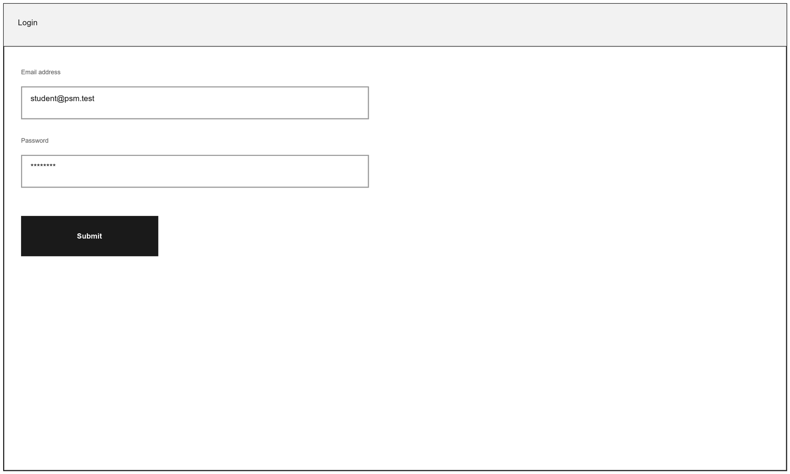
Figure 4.15: Login Screen

4.4.2 Lampiran A Registration Screen
The Lampiran A screen records the student's particulars and up to three proposed titles. It also records the supervisor they approached. The session is a dropdown of open terms. The supervisor list offers only staff of the student's programme. It also offers only those with capacity.

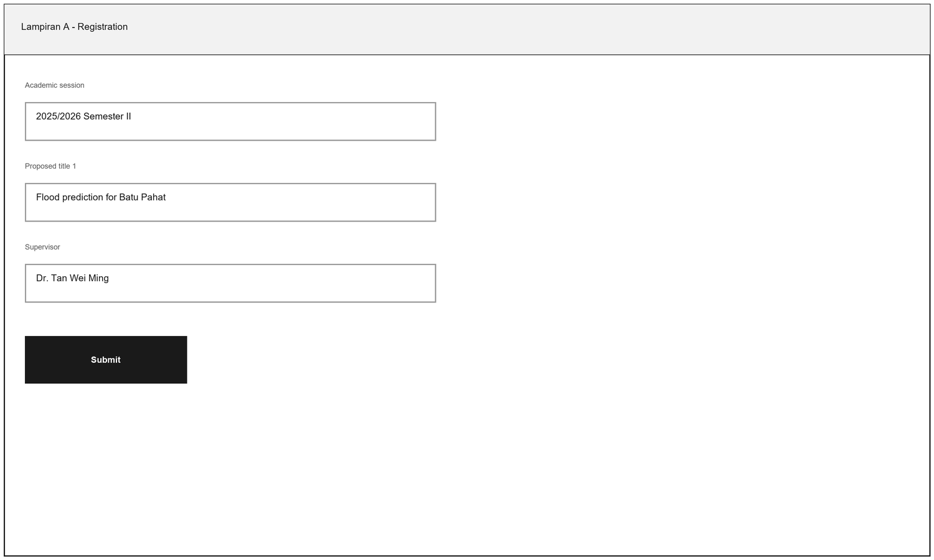
Figure 4.16: Lampiran A Registration Screen

4.4.3 Lampiran B Filing Screen
The Lampiran B screen records the project type and the field of study. It also records the software, hardware and technology required. The supervisor signs it here. Signing opens the proposal milestone.

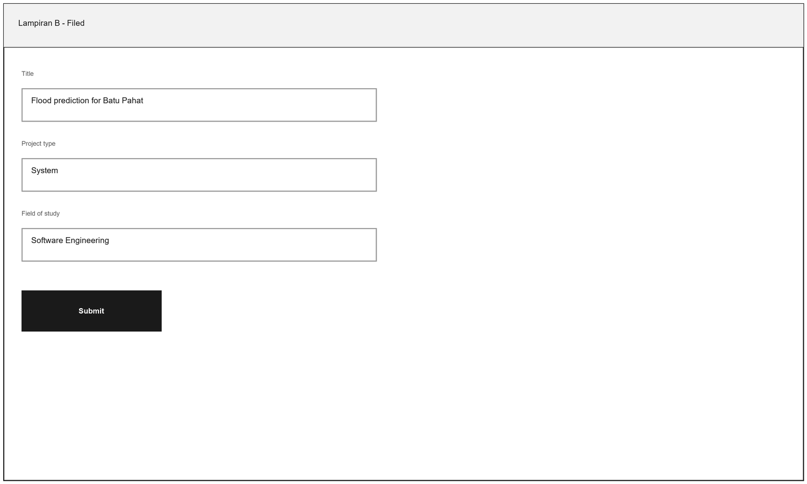
Figure 4.17: Lampiran B Filing Screen

4.5 Chapter Summary
This chapter presented the analysis and design of the system. It began with the system modules. It then gave the functional and non-functional requirements. The users' requirements followed. These were the use case diagram and six specifications. Each specification carried its history log and its actors. Each also carried its flows and exceptions, followed by both diagrams.
The design was then presented. The class diagram described the domain classes. The database design gave the core tables. It also gave a data dictionary for eight tables. The interface design described three screens. These carry registration and the Lampiran forms.
The next chapter presents the implementation. It also reports the testing carried out, including User Acceptance Testing.

